BAPTIST CHURCH

pe02110_

August Nursery Schedule

5 0-2 Year Olds Paula Knobloch

3-4 Year Olds Kristi Suchomel

12 0-2 Year Olds Ashley Smothermon

3-4 Year Olds Becky Yount

19 0-2 Year Olds Otisann McManus

3-4 Year Olds Karen Cotton

26 0-2 Year Olds Yoli Oliver

3-4 Year Olds Terri Edwards

**Other Contacts**

*Cleyon Davis – Treasurer*

(512) 856-2524

*Kimberly Tabor – Office Manager*

(512) 698-2804

**August Ushers**

Mickey Stanford, Terry Robinson

Hunter Wilson, Kregg Yount

**August Hostesses**

Mickey Stanford

Judie Coffey, Theresa Bartlett

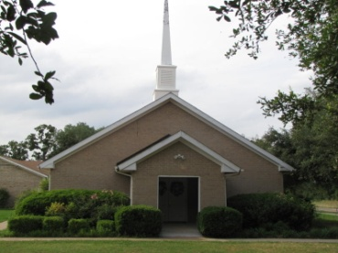

1662 CR 305

McDade, TX 78650

Phone: (512) 273-2743

Email: [KnobbsSpringsBaptist@gmail.com](mailto:KnobbsSpringsBaptist@gmail.com)



*KnobbsSpringsBC.com*

**Weekly Service & Activity Schedule:**

SUNDAY

Sunday School 9:45 a.m.

Morning Worship Services 11:00 a.m.

Youth Activities 5:30 p.m.

Evening Services 7:00 p.m.

MONDAY

“Work-It-On-Out” 6:30 p.m.

WEDNESDAY

“Work-It-On-Out” 6:00 p.m.

Youth Worship 6:30 p.m.

Wednesday Services 7:00 p.m.

THURSDAY

“Work-It-On-Out” 6:30 p.m.

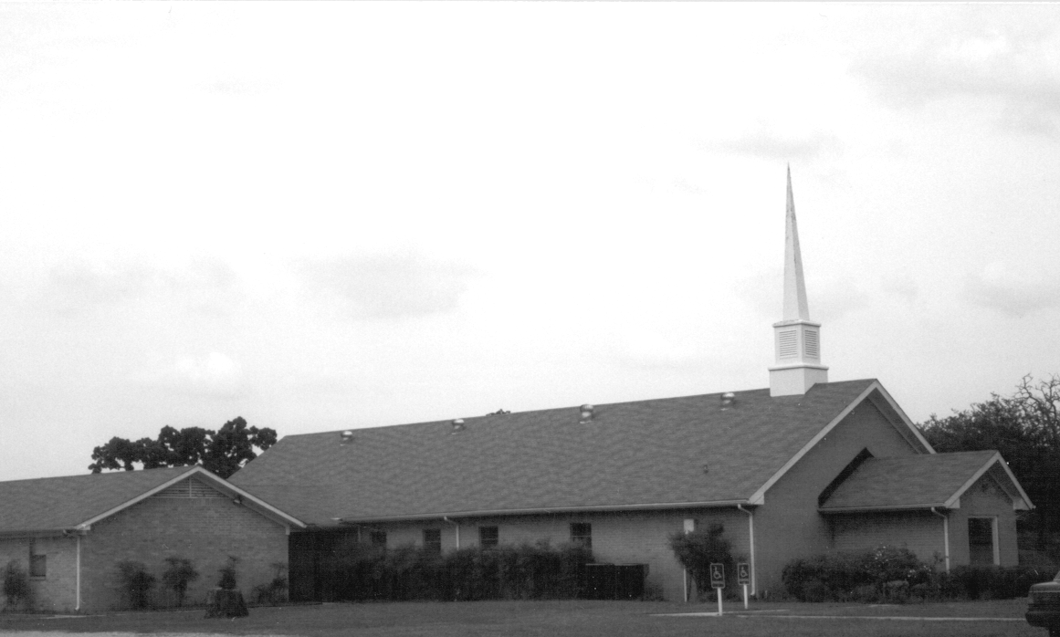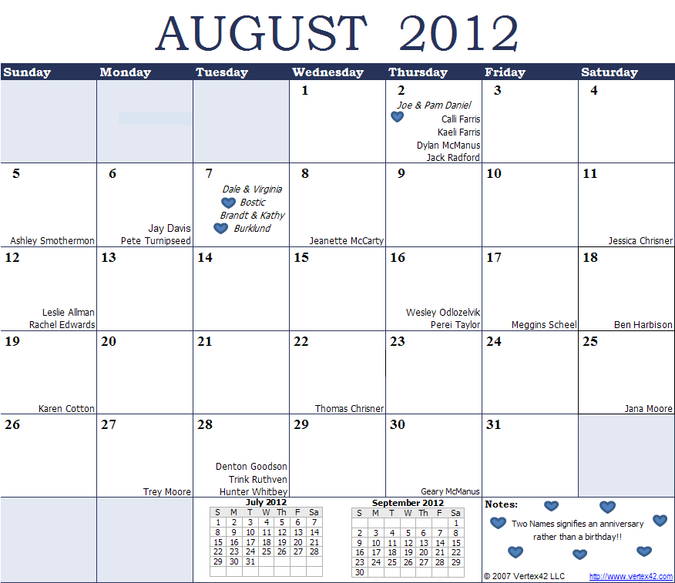

Please email KnobbsSpringsBaptist@gmail.com to be removed from our mailing list. Thanks!

August Newsletter

Knobbs Springs Baptist Church

1662 CR 305

McDade, TX 78650

Non-Profit Organization

U. S. Postage Paid

Permit # 1

McDade, Texas